Module 1: What RAG Is and Why We Need It
Hi! Imagine you are running an online shop that sells phones, clothes, and electronics.
A customer messages:
“Can I return an opened perfume bottle?”
You ask a normal ChatGPT or Grok (without any special setup):
It might say something like:
“Yes, most shops allow returns within 30 days even if opened. Just keep the box.”
But your real shop rule is:
Perfume is non-returnable once opened unless damaged.
→ The AI just made up a nice-sounding answer. This is called hallucination, the model sounds confident but is wrong.
Here is a funny picture that shows exactly this problem:
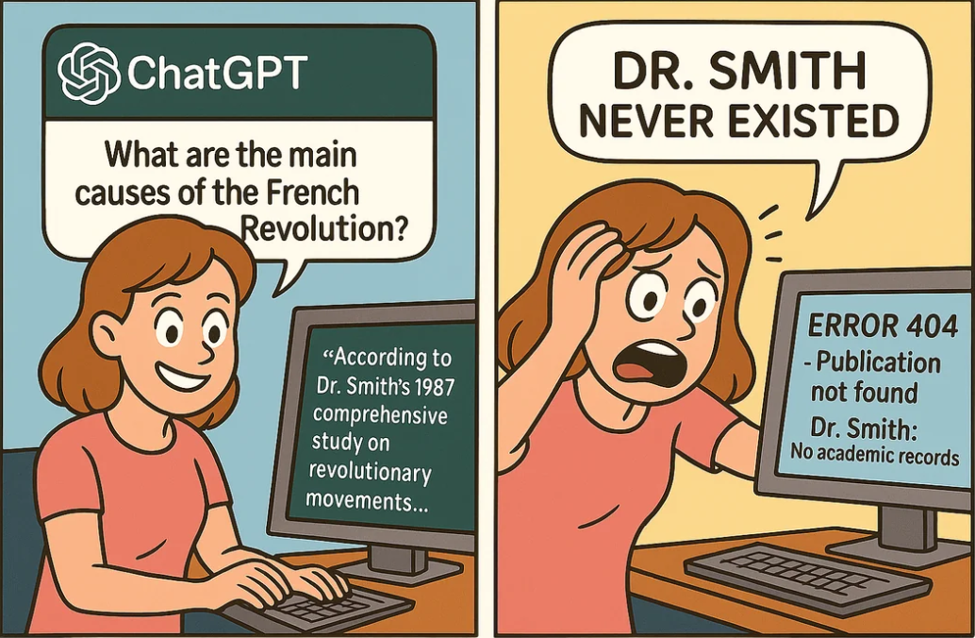

Normal LLM = Like a very smart friend who read many books… but stopped reading in 2024 (or whenever it was trained)
It only knows what was in its training.
- No latest return policy from your shop
- No private company docs
- No new product specs released last week
- No internal bank rules that changed yesterday
So when the question needs fresh or private info → it either:
- Says “I don’t know” (boring answer)
- Or guesses and sounds very sure → hallucination (dangerous in support, finance, medicine)

RAG = Giving your AI its own private library + a researcher
RAG is not a new AI model.
It is just a smart way to work:
- Build a search library from your documents (policies, FAQs, manuals)
- When question comes → quickly find the right pieces
- Give those pieces to the AI → now it writes answer using only real info
Look at this simple side-by-side picture:
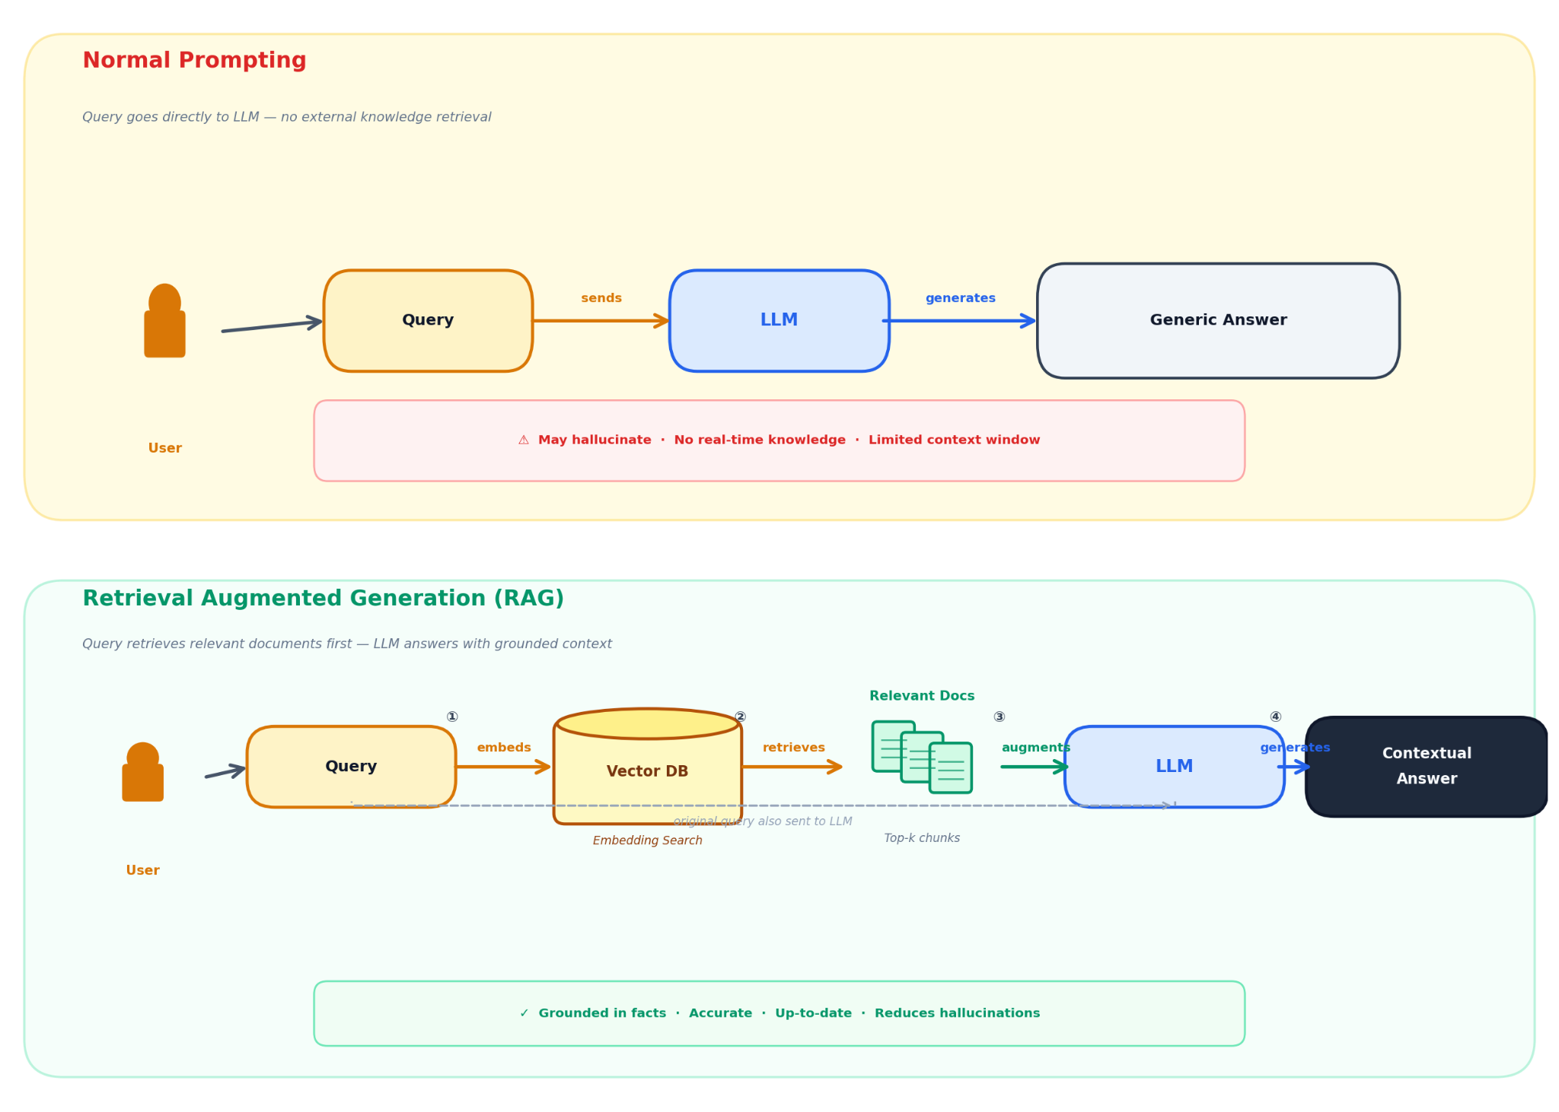
Top = normal LLM (just prompt → answer, can make up stuff)
Bottom = RAG (query → search database → get real docs → give to LLM → correct answer)

The three easy jobs inside every RAG system
Think of it like a small team helping the AI:
- Indexer (the librarian)
  - Takes all your PDFs, web pages, Word files
  - Cleans them, cuts into small pieces, turns into numbers (embeddings)
  - Saves in special fast-search database → Done once (or when docs change)
- Retriever (the quick researcher)
  - When customer asks question
  - Turns question into numbers
  - Searches database super fast
  - Brings back 3–10 most matching pieces
- Generator (the careful writer)
  - Gets question + the found pieces
  - Follows strict rules: “Only use what I gave you. Don’t guess!”
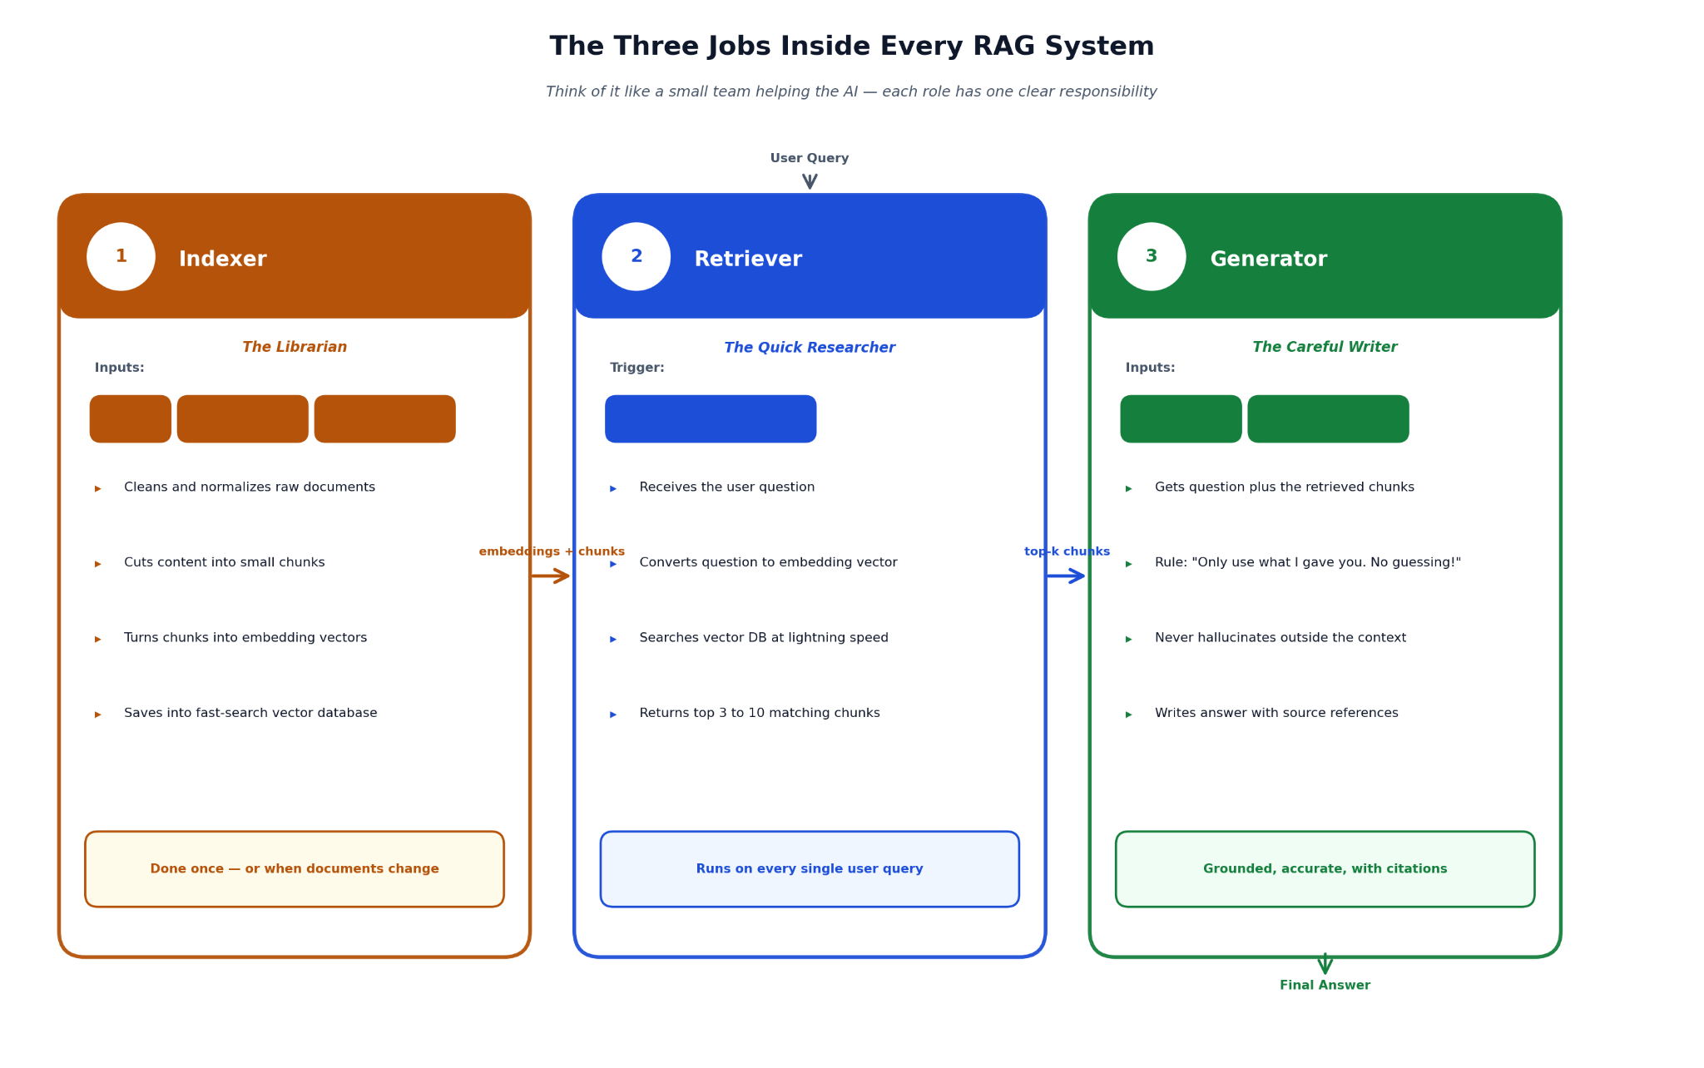
  - Writes nice, correct answer (usually with source reference)

Full simple picture of how everything connects
Here are a few clear flowcharts so you can see the whole flow at once:

Quick real-life examples where RAG saves the day
- Your Mumbai online fashion store Customer:
“Can I return used earrings?”
Without RAG → AI says “yes 15 days” (wrong)
With RAG → finds your exact policy: “Jewellery non-returnable if worn” → correct answer
- Bank customer care:
“Can I update my PAN online if the name is slightly different?”
Without RAG → old or made-up advice → compliance problem
With RAG → pulls latest RBI guideline → safe answer
- Medicine app
“Can I take this tablet with milk?”
Without RAG → dangerous guess
With RAG → exact leaflet text → “avoid dairy products”

Small pseudo code to feel the difference (try yourself)
Let us pretend we use very simple Python + open-source stuff.

# Imagine normal LLM (like fake ChatGPT without RAG)
def normal_llm_answer(question):
# This is what normal AI does — no real docs
if "return" in question.lower():
return "Yes, you can return within 30 days!"
return "I think yes..."

print(normal_llm_answer("Can I return opened perfume?"))
# Output: Yes, you can return within 30 days! ← Wrong for many shops!
Now imagine RAG version (just idea, full code later):
# Fake RAG version
your_real_rules = [
"Perfume once opened cannot be returned unless damaged.",
"Clothes return within 14 days with tags."
]

def rag_answer(question):
# In real code we search vector DB here
found = "Perfume once opened cannot be returned unless damaged."
return f"According to our policy: {found}"

print(rag_answer("Can I return opened perfume?"))
# Output: According to our policy: Perfume once opened cannot be returned unless damaged. ← Correct!

When to use RAG (and when to skip)
Use RAG when:
- You need exact, up-to-date, or private info (shop rules, bank policies, product manual, medical advice)
- Hallucination can cause loss (money, trust, legal trouble)
Skip RAG when:
- Just fun chat, poem writing, general knowledge everyone knows
- You need super fast answer (under 200 ms)
- No documents to search
We have covered: why normal AI fails, what RAG really is, the three roles, pictures to see it clearly, real examples, and tiny code taste.

Module 2: Step 1 – Making Your Searchable Library (Ingestion)
This is the offline part, you do it once (or when your documents change).
Think of it as building a smart library before any customer asks a question.
Why do we need this step?
Raw files (PDF manuals, Word policies, web FAQs) are not searchable by meaning.
We turn them into small pieces that a computer can understand and find quickly using "meaning" (not just keywords).
The Indexer (our librarian friend) does four main jobs:

1. Collect and clean documents
You gather all important files:
- Shop return policy PDF
- Bank KYC rules webpage
- Medicine patient info leaflet
- Tech support troubleshooting articles
These come in different formats → PDF, HTML, DOCX, etc.
First job: turn everything into plain clean text + save extra info like title, date, page number (called metadata).
Real world example: Your Mumbai fashion e-commerce site has a 20-page return policy PDF.
You extract text so later we can search sentences like "electronics non-returnable if opened".
Picture of this step:
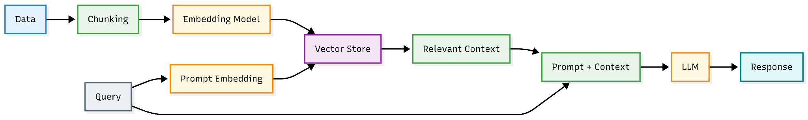
See how raw docs go into "text extraction" box.
Simple code to try (needs pip install pypdf2 or unstructured, but let's show idea):
# Simple example - read PDF and get text
from pypdf import PdfReader

reader = PdfReader("your_return_policy.pdf")
text = ""

for page in reader.pages:
text += page.extract_text() + "\n"

print(text[:300]) # first 300 chars to see
# Output: something like "Return Policy\n1. General Rules\nItems must be unused...\n"

In real projects use better tools like unstructured or llama-parse for tables/images too.

2. Chunking – cut big text into small bites
Why cut?
An 80-page guide is too big. If you search it, the whole thing comes back → LLM gets confused or hits the token limit.
We split into 300–800 token pieces (about 200–600 words).
Each chunk should hold one complete idea.
Tricks:
- Overlap (e.g. 20% overlap so no sentence gets cut in half)
- Split by paragraph or sentence
- Recursive: try to keep headings + content together
Example from your text:
80-page user guide → chunks like:
Chunk 1: "Chapter 1 - Returns for clothing"
Chunk 2: "Clothing returns within 14 days if tags are intact..."
Picture showing chunking:
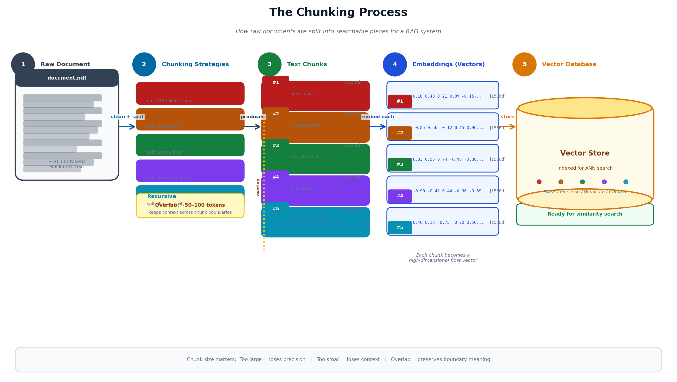
See long text → arrows to multiple small boxes.
Simple code (using langchain style – pip install langchain-text-splitters):
from langchain_text_splitters import RecursiveCharacterTextSplitter

splitter = RecursiveCharacterTextSplitter(
chunk_size=500, # characters
chunk_overlap=100, # overlap to keep context
separators=["\n\n", "\n", ".", " "]
)

chunks = splitter.split_text(your_long_text)

print(len(chunks)) # how many pieces
print(chunks[0][:150]) # see first chunk

3. Embedding – turn text into meaning numbers
Now each chunk becomes a list of numbers (vector) that captures meaning.
Similar meanings = close numbers.
Example from your text:
Query "refund for damaged product"
Should match chunk "replacement for defective item" — even no same words!
Embedding model does this magic.
Popular free ones: all-MiniLM-L6-v2 (small & fast)
Paid good one: text-embedding-3-small from OpenAI
Picture of embeddings in space:
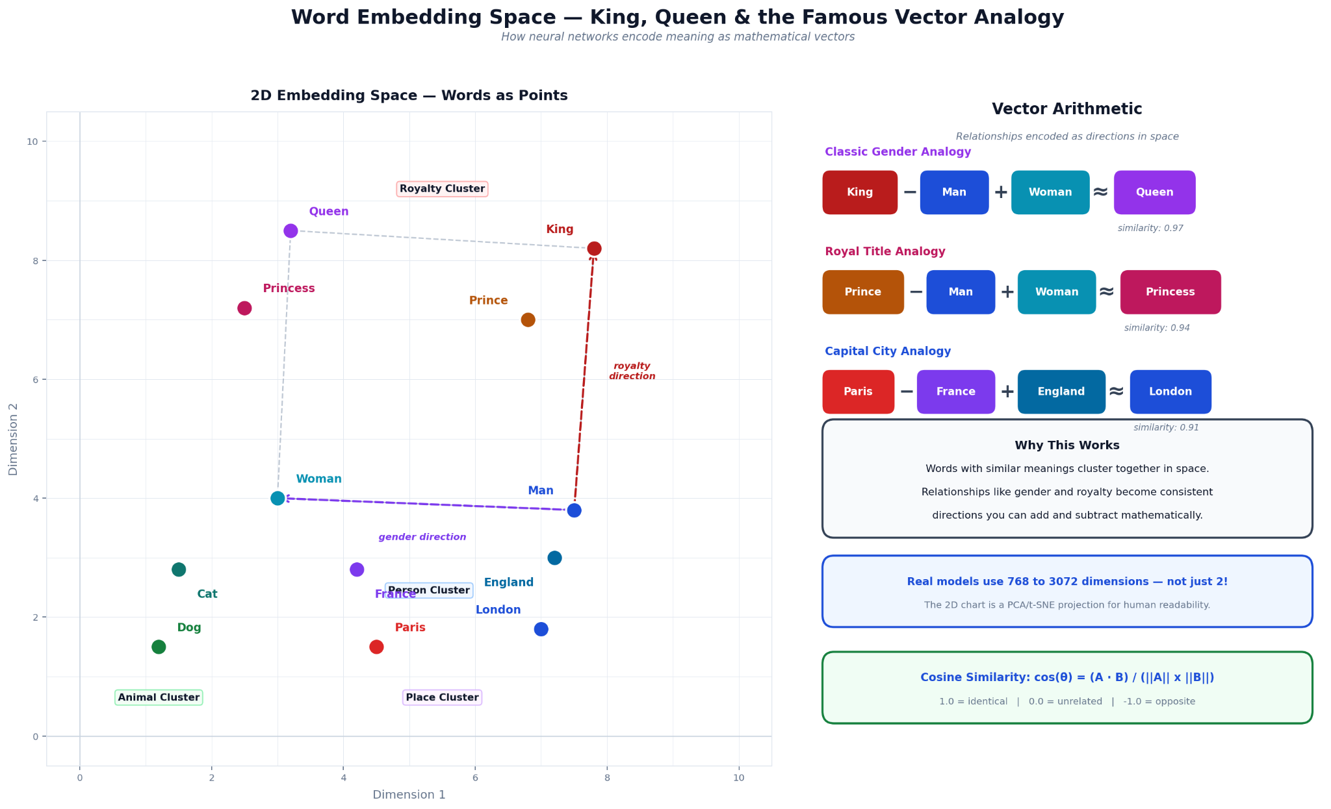
See how "king" and "queen" are close, words with similar meaning group together.
Simple code (pip install sentence-transformers):
from sentence_transformers import SentenceTransformer

model = SentenceTransformer('all-MiniLM-L6-v2')

chunks = ["Clothing return within 14 days if tags intact.",
"Electronics non-returnable once opened unless defective."]

embeddings = model.encode(chunks)

print(embeddings.shape) # e.g. (2, 384) → 2 chunks, 384 numbers each
print(embeddings[0][:5]) # first 5 numbers of first chunk

4. Indexing into a vector database
Save every chunk + its embedding + metadata into a special DB.
This DB is built to find "closest" vectors very fast (even millions of them).
Popular easy/free ones:
- Chroma (runs on your laptop)
- FAISS (fast)
- Pinecone (cloud, paid)
It uses tricks like HNSW to search quickly.
Picture of vector DB: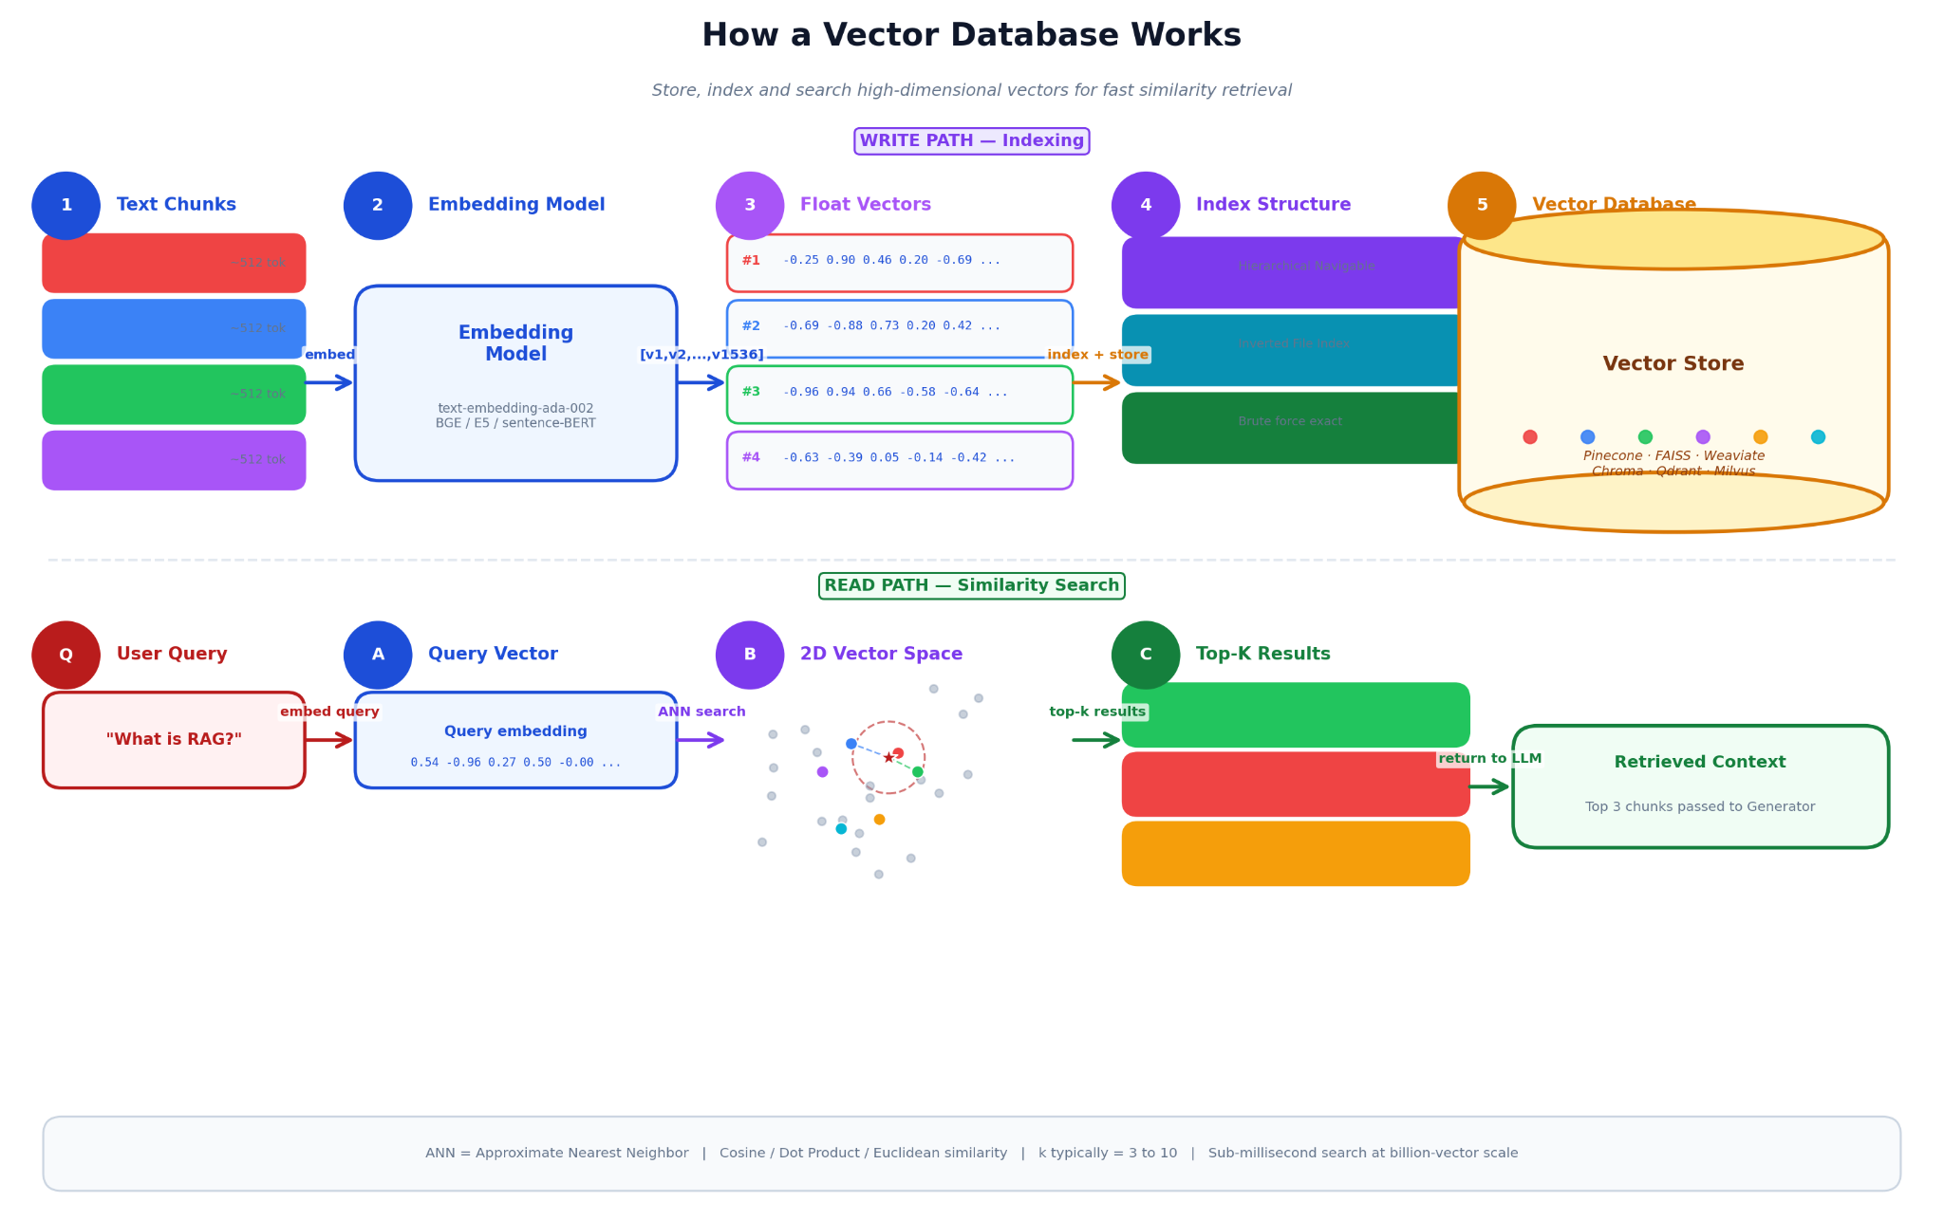

Real examples from different jobs
- E-commerce (your Mumbai shop): Ingest return policies, FAQs, warranties → answer "Can I return opened perfume?" correctly
- Banking: KYC rules, chargeback policy → safe answers for "update PAN online?"
- Healthcare: Dosage, warnings → "take with food?" gets exact leaflet text
- SaaS/IT support: Runbooks, wikis → "password reset not working" finds exact steps
Here is a complete small ingestion code example using Chroma (pip install chromadb sentence-transformers langchain-text-splitters):
from langchain_text_splitters import RecursiveCharacterTextSplitter
from sentence_transformers import SentenceTransformer
import chromadb

# Fake documents (in real: read from files)
docs = [
"Return Policy: Clothing within 14 days with tags. Electronics non-returnable once opened unless defective.",
"Perfume is hygiene product - no return if opened."
]

# Chunk (even though small)
splitter = RecursiveCharacterTextSplitter(chunk_size=200, chunk_overlap=50)
chunks = []
for doc in docs:
chunks.extend(splitter.split_text(doc))

# Embed
model = SentenceTransformer('all-MiniLM-L6-v2')
embeddings = model.encode(chunks)

# Save to Chroma
client = chromadb.Client()
collection = client.create_collection("shop_policies")

for i, (chunk, emb) in enumerate(zip(chunks, embeddings)):
collection.add(
documents=[chunk],
embeddings=[emb.tolist()],
ids=[f"chunk_{i}"],
metadatas=[{"source": "policy.pdf"}]
)

print("Library built! Ready for questions.")

Run this → you have a tiny searchable library!

Module 3: Step 2 and 3 – Finding the Right Info + Writing the Answer (Retrieval & Generation)
This is the online/runtime part :- happens every time someone asks something.
No more preparing — now we use the library we built in Module 2.
The flow is:
User question → find best matching pieces → give them to LLM with strict rules → get safe, correct answer.

Step 2 – Retrieval (the researcher at work)
When question arrives (e.g. "Can I return a used laptop?"):
Query embedding
Turn the question into the same kind of numbers (vector) we used for chunks.
- Must use exactly the same embedding model as in ingestion!
Vector search
Send a query vector to the vector DB.
It finds the closest (most similar meaning) chunks, usually top 3 to 10 (called top-k).
Uses cosine similarity (simple angle measure between vectors, closer to 1 = more similar).
Formula from your text (don't worry, code handles it):
Cosine similarity = (q · di) / (|q| |di|)
- → Just means how aligned the directions are.
Why this step is make-or-break
If wrong chunks come back → LLM writes beautiful but wrong answers.
- Common problems:
  - Misses important parts (bad chunking)
  - Old info (no date filter)
  - Noisy results (pure vector search bad for rare words) Fixes: hybrid search (vector + keywords), reranking, metadata filters (e.g. latest date), bigger k.
Pictures to see retrieval clearly:
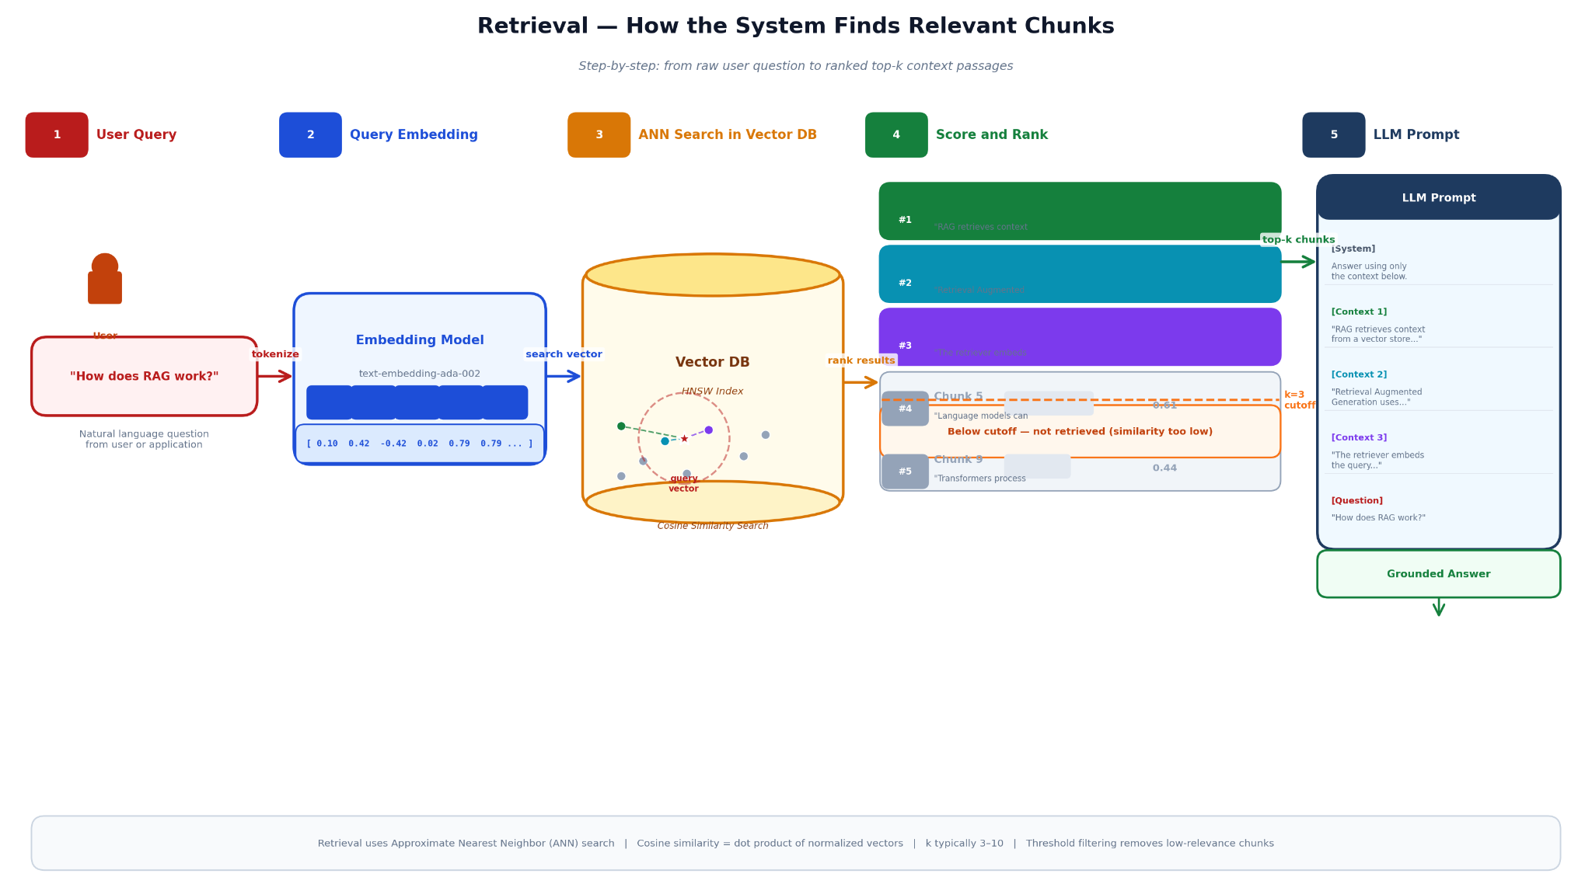
Cosine similarity:
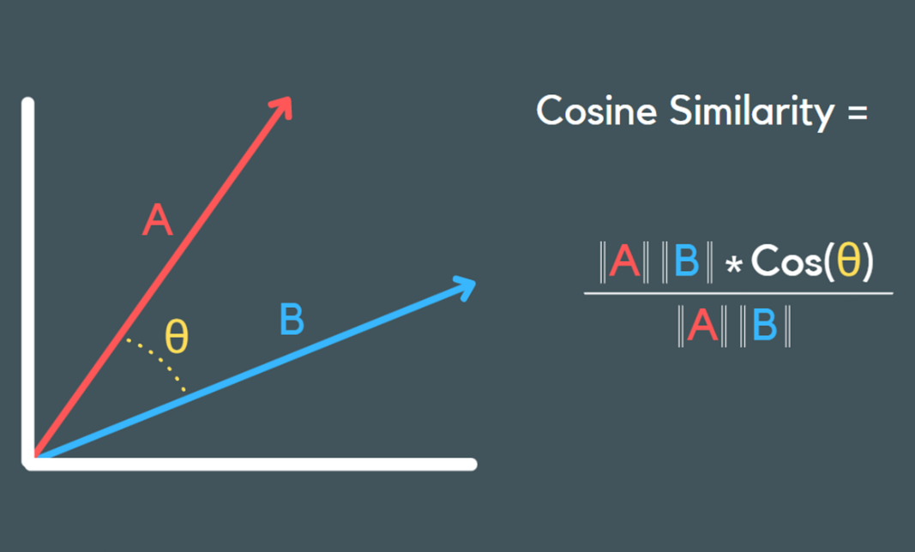

Real examples from your text (retrieval in action)
- E-commerce returns Question: “I opened the package. Can I still return it?” Good retrieval pulls:
  - Clothing: 14 days if tags intact
  - Electronics: non-returnable once opened unless defective
  - Damaged: replacement possible → Together they give full correct answer.
- Product compatibility “Will this charger work with iPhone 15?” Pulls charger specs (USB-C PD) + iPhone needs (20W+) → "Yes, but use 20W+"
- Banking KYC “Can I update my PAN card details online?” Pulls latest procedure: OTP ok, big name change needs visit, 2-5 days.
- Healthcare “Can I take this medicine with food?” Pulls exact leaflet: after meals to reduce nausea, avoid alcohol, consult if pregnant.

Step 3 – Generation (the careful writer)
Now LLM gets:
- Original question
- Top-k chunks as "context"
- Strict instructions: "Only use this context. Don't guess. If missing info → say so. Add citations."
- Prompt augmentation — stuff chunks into prompt with labels
- Grounding instructions — force truth
- Answer synthesis — LLM combines, summarizes, adds warnings.
Strong prompt example from your text:
You are a helpful support agent. Answer using **only** the information in the context below.

Rules:
- Never use your general knowledge
- If not enough info → say "I don't have enough information"
- Use citations like [1], [2]
- Be clear and accurate

Context:
[1] Clothing return within 14 days if tags intact...
[2] Electronics non-returnable once opened unless defective...

Question: {user question}

Bad vs good:
Without rules → LLM adds made-up "30-day policy"
With rules → sticks to real chunks.
Picture of generation:
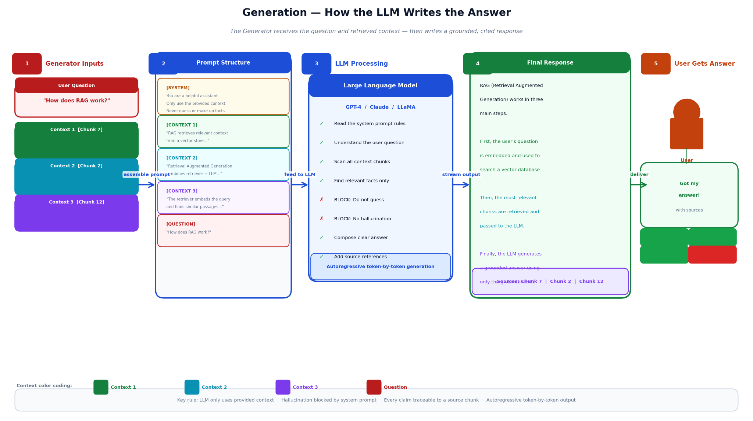

Simple code to try retrieval + generation
Build on Module 2's Chroma collection.
from sentence_transformers import SentenceTransformer
import chromadb
from openai import OpenAI # or use groq, ollama, etc. for free LLM

# Load same stuff
model = SentenceTransformer('all-MiniLM-L6-v2')
client = chromadb.Client()
collection = client.get_collection("shop_policies") # from Module 2

# Fake question
question = "Can I return an opened perfume?"

# 1. Embed query
query_emb = model.encode(question).tolist()

# 2. Retrieve top-k
results = collection.query(
query_embeddings=[query_emb],
n_results=3,
include=["documents", "metadatas"]
)

# Show what came back
print("Found chunks:")
for i, doc in enumerate(results["documents"][0]):
print(f"[{i+1}] {doc}")

# 3. Build prompt for LLM (use any LLM - here example with OpenAI style)
context = "\n".join([f"[{i+1}] {doc}" for i, doc in enumerate(results["documents"][0],1)])

prompt = f"""
You are a helpful support agent. Answer using **only** the context below.
Rules:
- Never guess or add extra facts
- If not enough info, say "I don't have enough information"
- Use citations like [1]

Context:
{context}

Question: {question}
Answer:
"""

# Call LLM (replace with your API key or local model)
# Example with OpenAI:
# llm = OpenAI(api_key="your-key")
# response = llm.chat.completions.create(model="gpt-4o-mini", messages=[{"role":"user", "content":prompt}])
# print(response.choices[0].message.content)

# Or just print prompt for now
print("\nPrompt sent to LLM:\n", prompt)
Run → see retrieved chunks → see prompt → imagine LLM answer using only real policy!

What can go wrong + easy fixes
- Ignores context → stronger rules in prompt
- Adds extra facts → "only use context" + "no general knowledge"
- Conflicts (old vs new) → filter metadata date, tell LLM "prefer latest"
- Incomplete → instruct "say if missing" or ask follow-up
We have covered, why RAG, three roles, ingestion (Module 2), retrieval + generation (this module), examples, failures/fixes, flowcharts everywhere, and runnable code pieces.

